## 

|  |
| --- |
| **International School**  CAPSTONE PROJECT 1  **CMU-SE-450**  INTERFACE DESIGN DOCUMENT  Version 1.1  Date: 15 - Nov - 2020  Green Big5 Information System  Submitted by  Chinh, Huu Thai  Chung, Bao Hoang  Loc, Tien Nguyen  Hau, Phuc Bui  **Approved by**  **Capstone Project 1 - Mentor:**  Name Signature Date  Binh, Thanh Nguyen \_\_\_\_\_\_\_\_\_\_\_\_\_\_\_\_\_\_31 - Nov- 2021 |

|  |  |  |  |
| --- | --- | --- | --- |
| **PROJECT INFORMATION** | | | |
| **Project Acronym** | GB5 | | |
| **Project Title** | GreenBig5 | | |
| **Project Web URL** | [http://greenbig5.herokuapp.com/](about:blank) | | |
| **Start Date** | 19 - Aug - 2021 | | |
| **End Date:** |  | | |
| **Lead Institution** | International School, Duy Tan University | | |
| **Project Mentor** | Doctor. Habil. Binh, Thanh Nguyen | | |
| **Scrum Master** | Chinh, Huu Thai | huuchinhdev@gmail.com | 0962.545.506 |
| **Team Members** | Hau, Phuc Bui | bphau121020@gmail.com | 0775.522.365 |
| Chung, Bao Hoang | baochunga1@gmail.com | 0889.192.932 |
| Loc, Tien Nguyen | nguyentienloc18122000@gmail.com | 0932.478.789 |

|  |  |  |  |
| --- | --- | --- | --- |
| **DOCUMENT INFORMATION** | | | |
| **Document Title** | Interface Design Document | | |
| **Author(s)** | Team C1SE.02 | | |
| **Role** | [GB5] Interface\_Design\_v1.1 | | |
| **Date** | 15 - Nov - 2021 | File name | [GB5] Interface\_Design\_v1.1 |
| **URL** | http://greenbig5.herokuapp.com/ | | |
| **Access** | Project and CMU Program | | |

## REVISION HISTORY

|  |  |  |  |  |
| --- | --- | --- | --- | --- |
| **Version** | **Person(s)** | **Date** | **Description** | **Approval** |
| Draft | Chinh | 12 - Aug - 2021 | Initiate document | x |
| 1.0 | Chinh | 15 - Nov - 2021 | Finish content of interface design | x |
| 1.1 | Hau, Loc | 10-Dec-2021 | Update content of interface design | x |
|  |  |  |  |  |
|  |  |  |  |  |
|  |  |  |  |  |
|  |  |  |  |  |
|  |  |  |  |  |
|  |  |  |  |  |
|  |  |  |  |  |
|  |  |  |  |  |
|  |  |  |  |  |
|  |  |  |  |  |

# 

## TABLE OF CONTENTS

[REVISION HISTORY 2](#_Toc91635693)

[TABLE OF CONTENTS 3](#_Toc91635694)

[1. INTRODUCTION 4](#_Toc91635695)

[1.1. PURPOSE OF DOCUMENT 4](#_Toc91635696)

[1.2. INTENDED AUDIENCES 4](#_Toc91635697)

[1.3. DOCUMENT OVERVIEW 4](#_Toc91635698)

[2. DETAILED INTERFACE WEB DESIGN 5](#_Toc91635699)

[2.1. Loginpage 5](#_Toc91635700)

[2.2. Sidebar 7](#_Toc91635701)

[2.3. Dashboard page 8](#_Toc91635702)

[2.4. User page 9](#_Toc91635703)

[2.5. Question Page 10](#_Toc91635704)

[3. DETAILED INTERFACE APPLICATION DESIGN 14](#_Toc91635705)

[3.1. Sign In page 14](#_Toc91635706)

[3.2. Signup page 15](#_Toc91635708)

[3.3. Change Display-Name page 17](#_Toc91635709)

[3.4. PhoneNumber page 19](#_Toc91635710)

[3.5. Question page 20](#_Toc91635711)

# 

# INTRODUCTION

## PURPOSE OF DOCUMENT

This IDD of the GB5 system has the following purpose:

* Document the design of the user interface of functions of GB5.
* Be the primary document driving the implementation of the user interfaces.
* Introduce interface design for the reader. Including the background, content information display, command buttons.

## INTENDED AUDIENCES

This IDD is intended for the following audiences:

* Technical reviewers including:
* Scrum Master
* Product owner
* Implementers, including:
  + Developers.
  + Testers.

## DOCUMENT OVERVIEW

This IDD is organized into the following sections:

* This document helps to better understand the interface of the Green Big 5 information System, detailed specification components and function of the Application, Dashboard
* With this document, the development team can understand the structure and composition to create a consistent and complete system.
* Overview of the stages and modules of the software and create a complete interface.

# DETAILED INTERFACE WEB DESIGN

## Loginpage

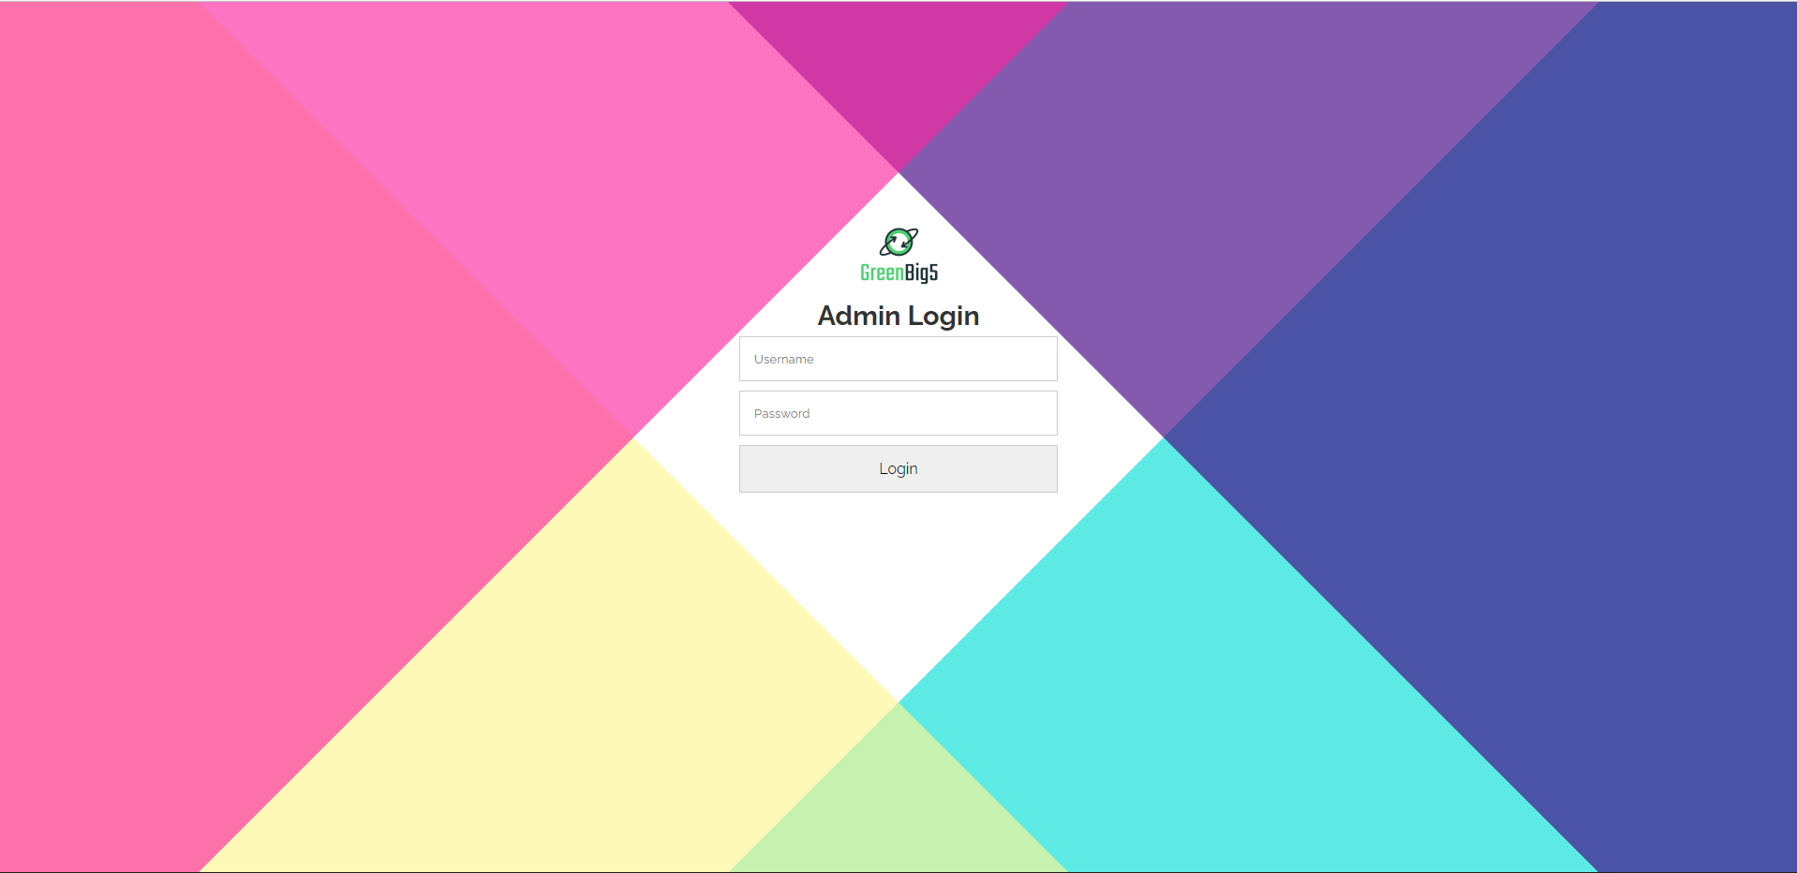

|  |  |  |  |  |
| --- | --- | --- | --- | --- |
| **Loginpage** | | | | |
| **No.** | **Field name** | **Type** | **Require** | **Target** |
| 1 | Background |  | .top:before {  transform: rotate(45deg);  background: #05dfd7;  }  .top:after {  transform: rotate(135deg);  background: #fff591;  }  .bottom:before {  transform: rotate(-45deg);  background: #400082;  }  .bottom:after {  transform: rotate(-135deg);  background: #fa26a0; |  |
| 2 | Header | H2 tag | Font-size: 1.2rem  Color: #00000 |  |
| 3 | Email | Input tag | width: 100%;  padding: 15px;  margin: 5px;  border-radius: 1px;  border: 1px solid #ccc;  font-family: inherit; |  |
| 4 | Password | Input “password” tag | width: 100%;  padding: 15px;  margin: 5px;  border-radius: 1px;  border: 1px solid #ccc;  font-family: inherit; |  |
| 5 | Button | button | cursor: pointer;  font-size: 1rem;  hover:  background-color: #28df99;  color: #ffffff; | Redirect to /dashboard page |
| 6 | logo | image |  | logo\_green.png |

## Sidebar

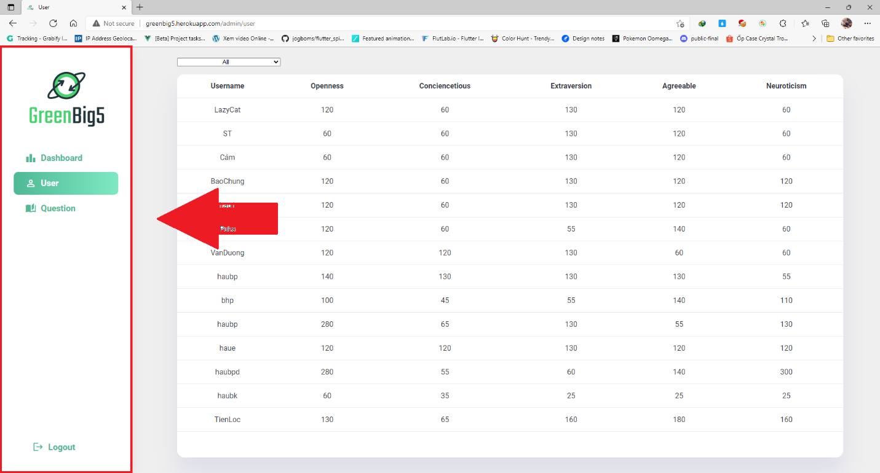

|  |  |  |  |  |
| --- | --- | --- | --- | --- |
| **Sidebar** | | | | |
| **No.** | **Field name** | **Type** | **Require** | **Target** |
| 1 | Logo | image |  | logo\_green.png |
| 2 | Menu | List & icon button | margin-top: 0.3rem;  padding: 13px 25px;  display: flex;  align-items: center;  font-weight: 600;  transition: color 0.2s ease 0s;  color: #4eb994;  position: relative  hover: color: #fff; | Dashboard, User, Question,  Logout |

## Dashboard page

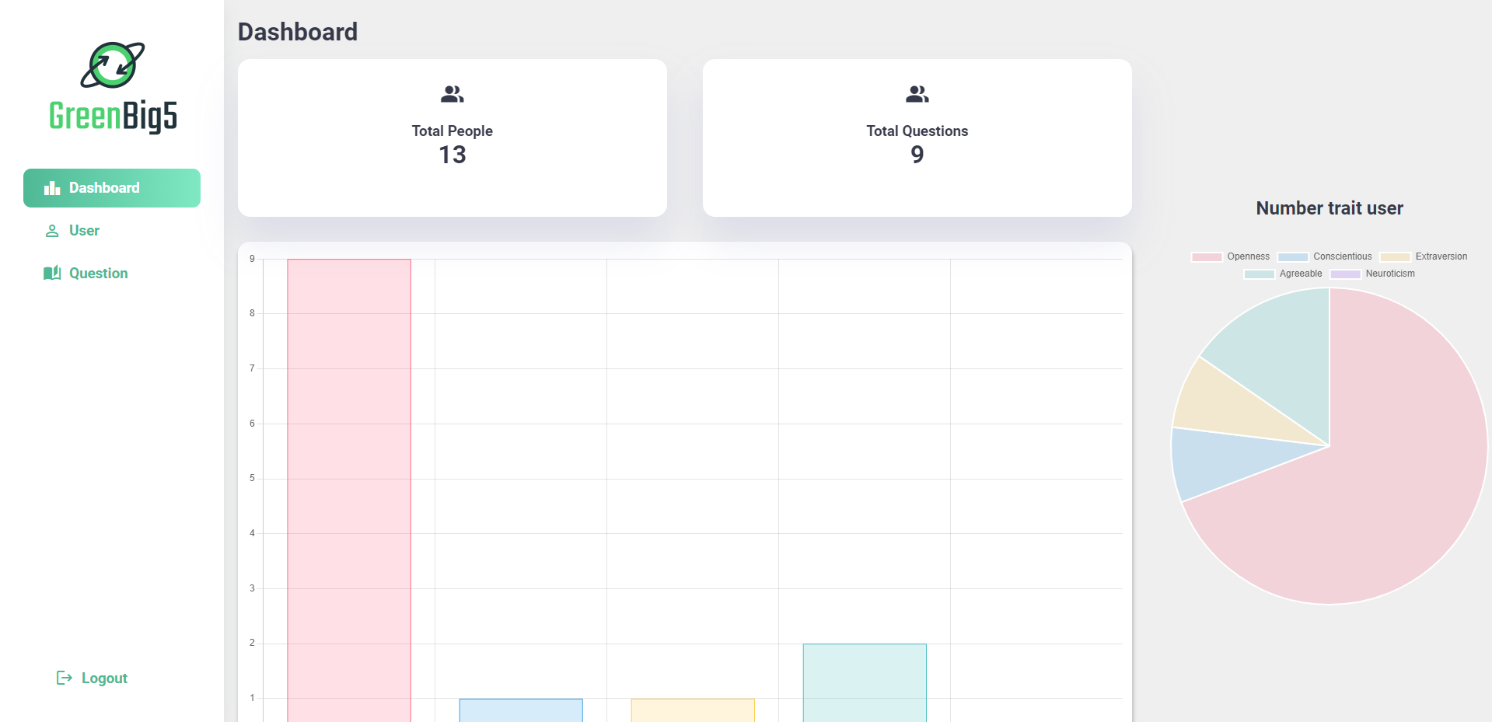

|  |  |  |  |  |
| --- | --- | --- | --- | --- |
| **Dashboard page** | | | | |
| **No.** | **Field name** | **Type** | **Require** | **Target** |
| 1 | Header | H1 | Color: #00000 |  |
| 2 | Card | div | background: var(--color-background);  padding: 1.8rem;  border-radius: 1rem;  width: 48%;  margin-top: 1rem;  box-shadow: var(--box-shadow); | Total people, total questions |
| 3 | Column chart | div | margin-top: 2rem;  height: 50%;  width: 100%;  background-color: white;  padding: 12px;  border-radius: 15px;  box-shadow: 1px 5px 5px 1px rgb(0 0 0 / 20%); |  |
| 4 | Pie Chart | div | Display: flex  display: block;  box-sizing: border-box;  height: 464px;  width: 464px; |  |

## User page

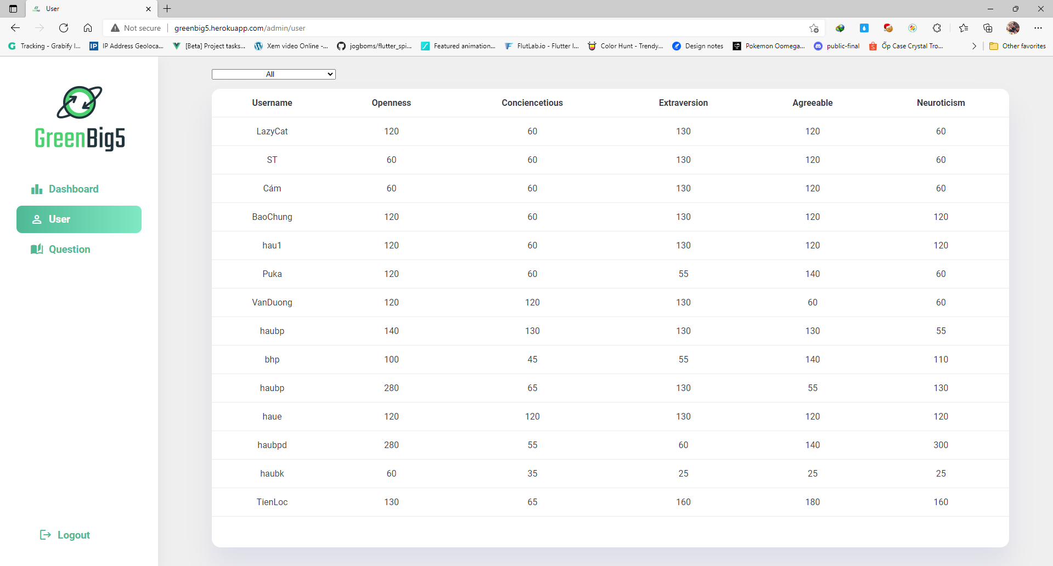

|  |  |  |  |  |
| --- | --- | --- | --- | --- |
| **User page** | | | | |
| **No.** | **Field name** | **Type** | **Require** | **Target** |
| 1 | Filter | Dropdown(Select tag) | All: Openness, Conciencetious, Extraversion, Agreeable, Neuroticism. | |
| 2 | Table | Table tag | margin: 0 auto;  width: 90%;  overflow-y: auto;  height: 70vh;  background:var(--color-background);  border-radius: 1rem; |  |

## Question Page

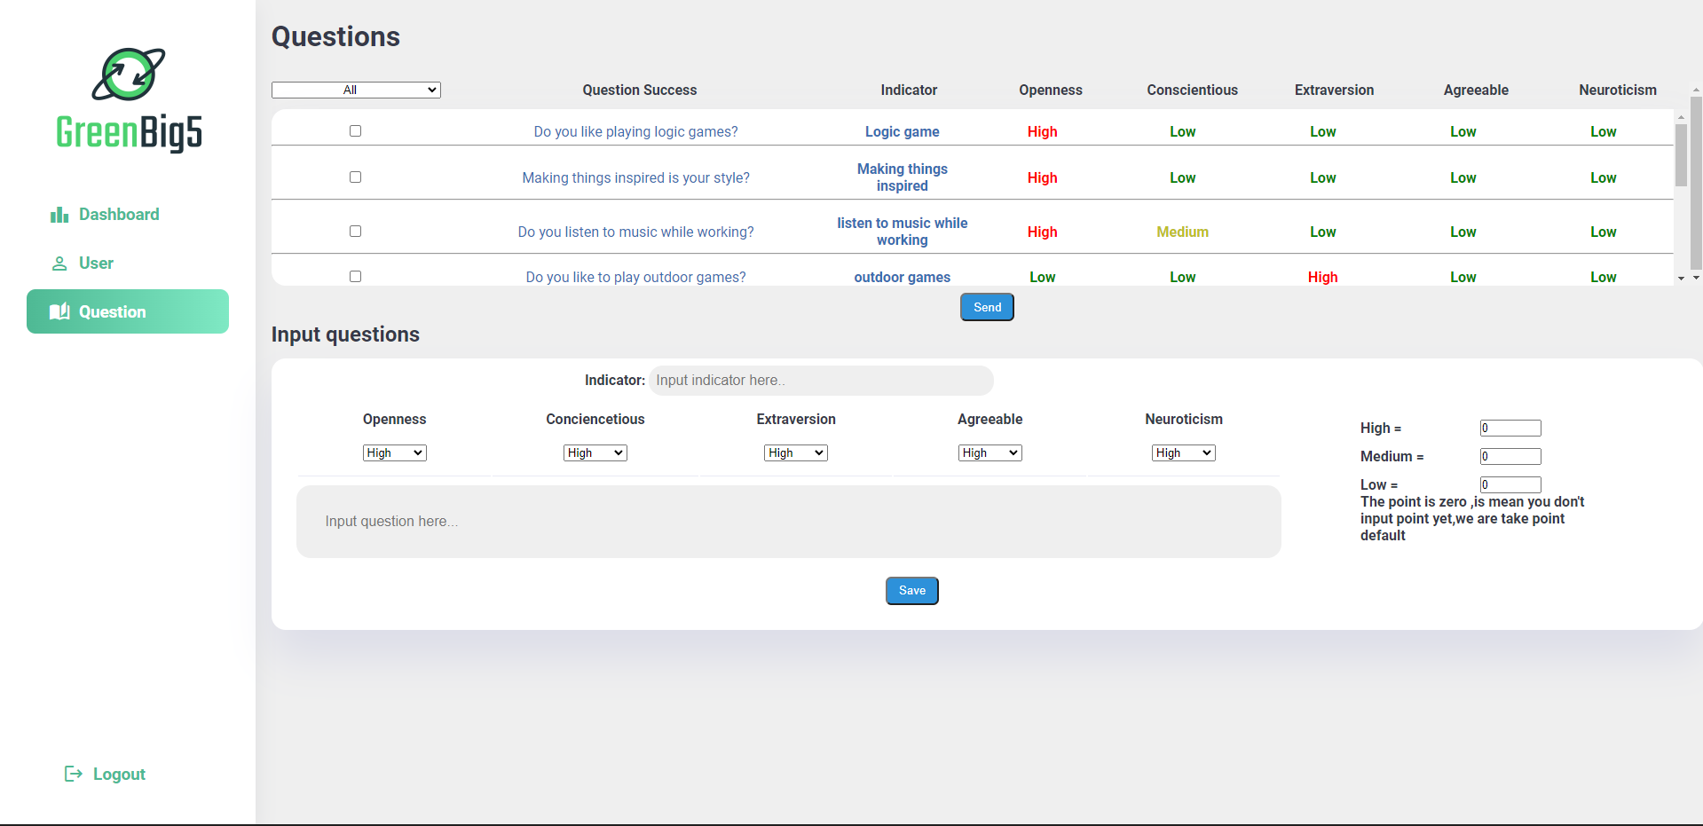

|  |  |  |  |  |
| --- | --- | --- | --- | --- |
| **Question Page** | | | | |
| **No.** | **Field name** | **Type** | **Require** | **Target** |
| 1 | background |  | margin-top: 1.4rem;  margin-left: 1.1rem;  position: relative;  background: #363949 |  |

* + 1. SHOW QUESTION FORM

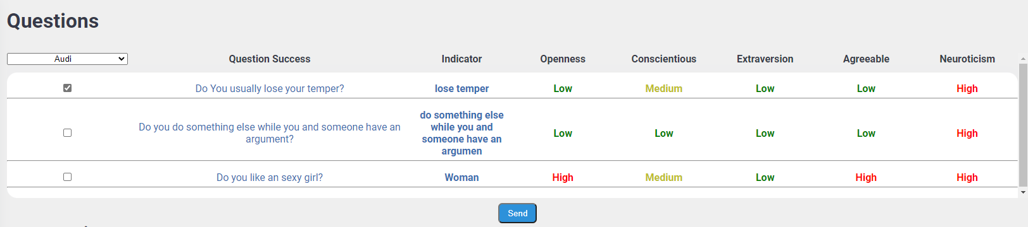

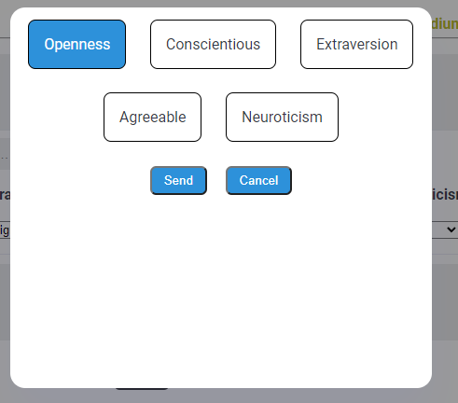

|  |  |  |  |  |
| --- | --- | --- | --- | --- |
| **Question Page** | | | | |
| **No.** | **Field name** | **Type** | **Require** | **Target** |
| 1 | Header | H1 | margin-bottom: 2rem; |  |
| 2 | Filter questions | Dropdown(Select tag) | All: Openness, Conciencetious, Extraversion, Agreeable, Neuroticism. | |
| 3 | Table | Table tag | height: 230px;  overflow: auto;  border-bottom-left-radius: 1rem;  border-bottom-right-radius: 1rem; |  |
| 4 | Table header | thead | display: flex;  text-align: center; |  |
| 5 | Table body | tbody | margin-top: 12px;  background: var(--color-background);  width: 100%;  height: 87%;  overflow: auto;  border-radius: 1rem;  border-bottom-right-radius: 1px;  text-align: center;  box-shadow: var(--box-shadow); |  |
| 6 | Select question | Input tag | Type “checkbox” | When you click, you will choose the question you want to manipulate |
| 7 | Send question | button | padding: 0.4rem 0.8rem 0.4rem;  cursor: pointer;  color: #fff;  background: #2d91da;  border-radius: 0.4rem; | When you click on it, a table will appear to choose to send a question |

* + 1. INPUT QUESTION FORM

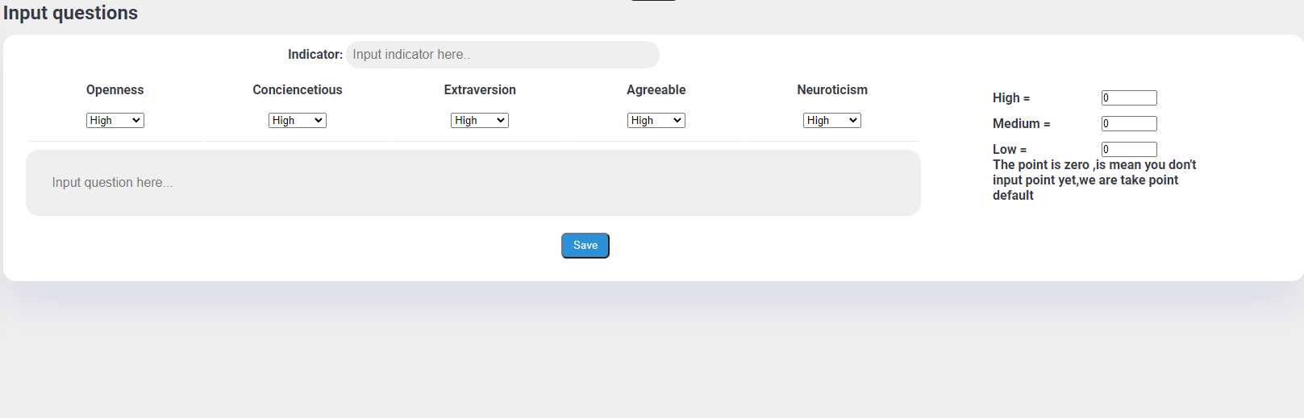

|  |  |  |  |  |
| --- | --- | --- | --- | --- |
| **Input Question Form** | | | | |
| **No.** | **Field name** | **Type** | **Require** | **Target** |
| 1 | Header | H2 | margin-bottom: 0.8rem; |  |
| 2 | Input indicator | Input tag | width: 35%;  padding: 0.5rem; |  |
| 3 | Poin | Input tag | type="number" min="1" max="100" value="0" |  |
| 4 | Input questions | Input tag | margin-top: 0;  background: var(--color-background);  border-radius: 1rem;  padding: 0 1.8rem 1.8rem 0;  box-shadow: var(--box-shadow);  text-align: center; |  |
| 5 | Save question | button | margin-top: 1.3rem;  padding: 0.4rem 0.8rem 0.4rem;  cursor: pointer;  margin-left: 25%;  color: #fff;  background: #2d91da;  border-radius: 0.4rem; | When onclick it save a question |

# DETAILED INTERFACE APPLICATION DESIGN

## Sign In page

## C:\Users\Admin\Downloads\263410768_932947374020260_877627630947904931_n.jpg

|  |  |  |  |  |
| --- | --- | --- | --- | --- |
| **Input Question Form** | | | | |
| **No.** | **Field name** | **Type** | **Require** | **Target** |
| 1 | Background |  | backgroundColor: Colors.white, |  |
| 2 | Header | Text | fontWeight: FontWeight.bold,  fontSize: 28.0 |  |
| 3 | Subtitle | Text | color: Colors.grey,  fontSize: 25.0, |  |
| 4 | Logo | Image |  | logo\_green.png |
| 5 | Input infomation | TextFormField | borderRadius:BorderRadius.all(Radius.circular(10.0)), | Phone number, password |
| 6 | Button | Button | fontSize: 20.0,  HexColor(“#2FBB89”)  borderRadius: BorderRadius.circular(12.0), | when onclick it go through the login process |
| 7 | Signup | Link | HexColor(“#2FBB89”) | When onclick make, you will be redirected to the signup page |

## Signup page

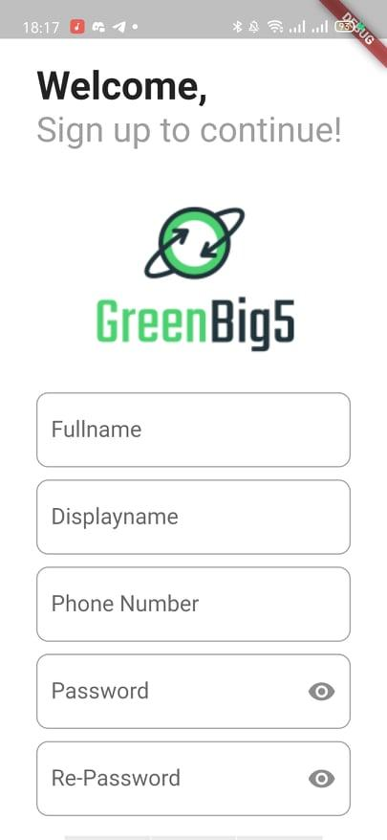

|  |  |  |  |  |
| --- | --- | --- | --- | --- |
| **Input Question Form** | | | | |
| **No.** | **Field name** | **Type** | **Require** | **Target** |
| 1 | Background |  | backgroundColor: Colors.white, |  |
| 2 | Header | Text | fontWeight: FontWeight.bold,  fontSize: 28.0 |  |
| 3 | Subtitle | Text | color: Colors.grey,  fontSize: 25.0, |  |
| 4 | Logo | Image |  | logo\_green.png |
| 5 | Input infomation | TextFormField | borderRadius:BorderRadius.all(Radius.circular(10.0)), | Full Name, Display Name, Phone number, password, Repassword |
| 6 | Button | Button | fontSize: 20.0,  HexColor(“#2FBB89”)  borderRadius: BorderRadius.circular(12.0), | when onclick it go through the login process |

## Change Display-Name page

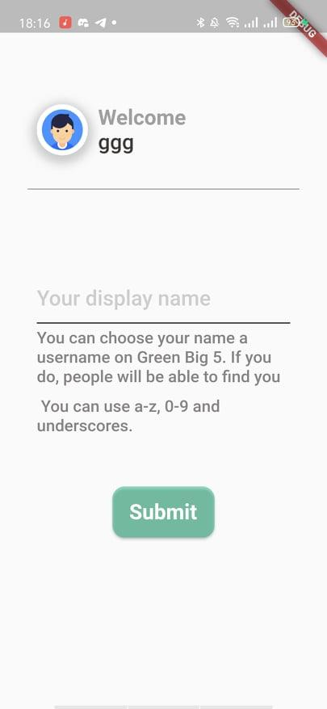

|  |  |  |  |  |
| --- | --- | --- | --- | --- |
| **Input Question Form** | | | | |
| **No.** | **Field name** | **Type** | **Require** | **Target** |
| 1 | Background |  | backgroundColor: Colors.grey, |  |
| 2 | Header | Text | color: Colors.grey,  fontSize: 24.0,  fontWeight: FontWeight.bold, |  |
| 3 | Subtitle | Text | color: Colors.black,  fontSize: 24.0, |  |
| 4 | Logo | Image | color: Colors.white, width: 5.0 | user.png |
| 5 | Change display name | TextFormField | fontSize: 18 | Enter to change your display name |
| 6 | Info | Text | fontSize: 14,  fontWeight: FontWeight.w500,  color: HexColor("#868383" |  |
| 7 | Button | Button | fontSize: 20.0,  HexColor(“#2FBB89”)  borderRadius: BorderRadius.circular(12.0), | when onclick it go through the login process |

## PhoneNumber page

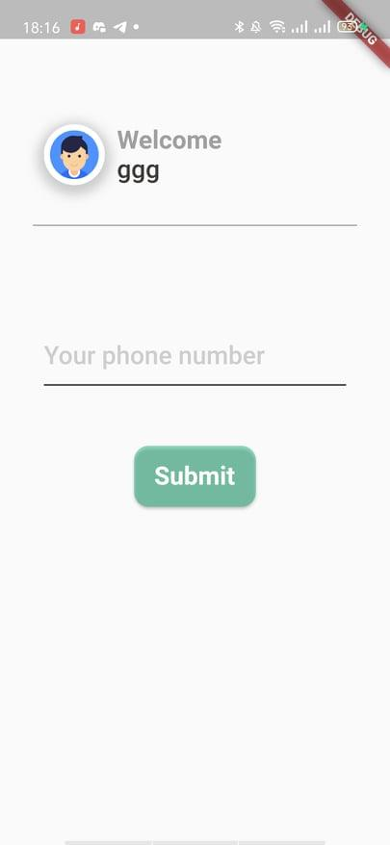

|  |  |  |  |  |
| --- | --- | --- | --- | --- |
| **Input Question Form** | | | | |
| **No.** | **Field name** | **Type** | **Require** | **Target** |
| 1 | Background |  | backgroundColor: Colors.grey, |  |
| 2 | Header | Text | color: Colors.grey,  fontSize: 24.0,  fontWeight: FontWeight.bold, |  |
| 3 | Subtitle | Text | color: Colors.black,  fontSize: 24.0, |  |
| 4 | Logo | Image | color: Colors.white, width: 5.0 | user.png |
| 5 | Phone Number | TextFormField | fontSize: 18 | Enter to change your phone number |
| 7 | Button | Button | fontSize: 20.0,  HexColor(“#2FBB89”)  borderRadius: BorderRadius.circular(12.0), | when onclick it go through the login process |

## Question page

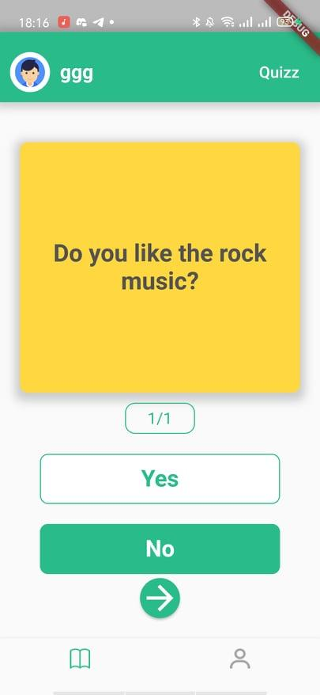

|  |  |  |  |  |
| --- | --- | --- | --- | --- |
| **Input Question Form** | | | | |
| **No.** | **Field name** | **Type** | **Require** | **Target** |
| 1 | Background |  | backgroundColor: Colors.grey, |  |
| 2 | Header |  | color: Colors.grey.withOpacity(0.5),  spreadRadius: 5, blurRadius: 7,  offset: Offset(0,0.2)  HexColor(“#2FBB89”) |  |
| 3 | Name | Text | fontWeight: FontWeight.w700, fontSize: 17.0,  color: Colors.white |  |
| 4 | Subtitle | Text | fontSize: 14.0,fontWeight: FontWeight.w500,  color: Colors.white, |  |
| 5 | Logo | Image | color: Colors.white, width: 5.0,  borderRadius: BorderRadius.circular(150.0), | user.png |
| 6 | Phone Number | TextFormField | fontSize: 18 | Enter to change your display name |
| 7 | Answer | Button (Option) | option(id, questionDefind, phoneNumber,"Yes",100.0),  SizedBox(width: 20.0,), option(id, questionDefind, phoneNumber,"No",100.0) | when onclick select the user's answer |
| 8 | Skip | Button (Option) | option(id,questionDefind,phoneNumber,"Skip",250.0) | when onclick skip question |